000님 session 00
Pregnancy — Part 2 (강사용)
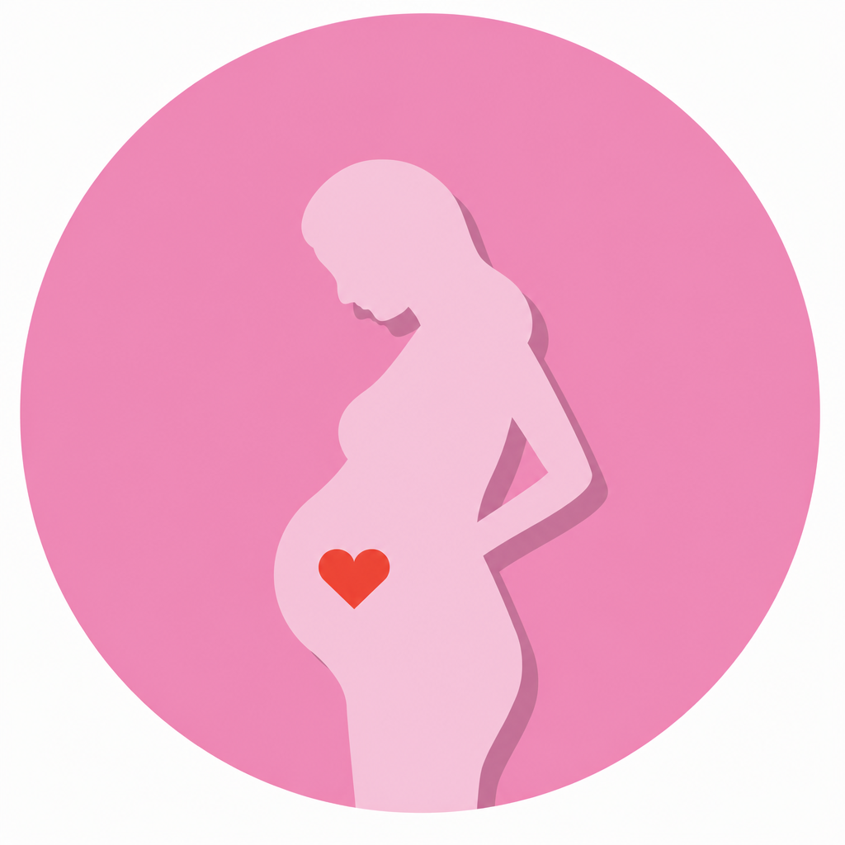
Research / Vocabulary Review / Dialogue Practice / Questions for Your Doctor

Research
Answer Yes or No for Korea. Then explain your answer to your teacher.
한국 기준으로 Yes/No 답한 뒤 이유를 설명하게 하세요.
1. | Midwives (nurses who help deliver babies) are available. | Yes / No
2. | The government helps pay for prenatal checkups. | Yes / No
3. | Home births are allowed. | Yes / No
4. | Pregnant women can find out the sex of their baby at an ultrasound screening. | Yes / No
5. | Pregnant women are tested for gestational diabetes in the second trimester. | Yes / No
6. | Pregnant women can ask for extra tests to check the baby's health. | Yes / No
7. | Epidurals are available at hospitals. | Yes / No
8. | A public health nurse makes a home visit after the baby goes home. | Yes / No
Vocabulary Review — Matching
Match the words on the left with the descriptions on the right.
왼쪽 단어와 오른쪽 설명을 연결하세요.
a) epidural | 1. ____ | With this temporary condition, you need to watch your sugar intake.
b) midwife | 2. ____ | This optional procedure can identify genetic abnormalities that a screening might not catch.
c) ob-gyn | 3. ____ | This refers to all pregnancy stages from conception to birth.
d) trimester | 4. ____ | This is the shortening of the uterine muscles during labor.
e) gestational diabetes | 5. ____ | This specialist can care for you during a high-risk pregnancy and birth.
f) gestation | 6. ____ | This allows a technician to see your baby in the womb.
g) due date | 7. ____ | This will reduce or prevent the feeling of pain during labor.
h) amniocentesis | 8. ____ | She helps you give birth comfortably in your home or at the hospital.
i) ultrasound | 9. ____ | This is the loss of a baby that is not ready to leave the womb.
j) contraction | 10. ____ | Each one lasts 12–14 weeks.
k) miscarriage | 11. ____ | This is the approximate day your baby is due.
l) lactation | 12. ____ | This is the production of milk so you can breastfeed your baby.

Dialogue Practice
Practice each dialogue with your teacher. Then switch roles.
역할을 바꿔가며 두 번씩 연습하세요.

Dialogue 1 — First Trimester: the first visit to the ob-gyn (A: doctor / B: mom-to-be)
A What brings you in today?
B Well, I took a home pregnancy test a few days ago, and… it was positive!
A Congratulations! When was your last period?
B About seven weeks ago, I think.
A Okay, that sounds about right. Is this your first pregnancy?
B Yes, it is. To be honest, I'm excited but a little nervous.
A That's completely normal. How have you been feeling? Any fatigue or nausea?
B I feel nauseous in the mornings, and I get really tired in the afternoons.
A Morning sickness and fatigue are very common in the first trimester. Try eating small meals more often, and get as much rest as you can.
B Is there anything I should avoid?
A Cut down on caffeine, skip alcohol completely, and stay away from raw fish for now. Also, start taking folic acid if you haven't already.
B Okay. When will I be able to see the baby?
A Let's do a quick ultrasound today to check the heartbeat and confirm your due date. After that, I'll see you every four weeks for prenatal checkups.
B That sounds great. Thank you, Doctor.

A 오늘 어떻게 오셨어요?
B 며칠 전에 임신 테스트기를 해봤는데… 양성이 나왔어요!
A 축하드려요! 마지막 생리가 언제였죠?
B 7주 정도 전인 것 같아요.
A 네, 시기가 맞네요. 첫 임신이세요?
B 네. 솔직히 설레는데 조금 긴장돼요.
A 아주 자연스러운 거예요. 몸은 어떠셨어요? 피로감이나 메스꺼움은요?
B 아침에는 메스껍고, 오후에는 많이 피곤해요.
A 입덧과 피로는 임신 초기에 아주 흔해요. 조금씩 자주 드시고, 최대한 쉬세요.
B 피해야 할 게 있을까요?
A 카페인은 줄이고, 술은 완전히 끊고, 당분간 날생선은 피하세요. 그리고 엽산을 아직 안 드시면 시작하세요.
B 네. 아기는 언제 볼 수 있어요?
A 오늘 간단히 초음파로 심장박동을 확인하고 출산 예정일을 잡을게요. 그다음부터는 4주마다 산전 검진으로 뵐게요.
B 좋아요. 감사합니다, 선생님.

Dialogue 2 — Second Trimester: the 20-week ultrasound (A: doctor / B: mom-to-be)
A Did you drink plenty of water before coming in?
B Yes, I did. I learned my lesson last time!
A Good. Okay, just relax and lie back. I'm going to put some gel on your belly — it's a little cold.
B Oh, that is cold!
A Sorry about that. So, you're 20 weeks today, right?
B Yes. Halfway there!
A Let's see… Here's the head, and here's the spine. The baby is moving quite a lot today.
B Oh wow, I can see the little hands! Can we find out the baby's sex today?
A If the baby cooperates, yes. Is your husband here?
B He's in the waiting room. Can he come in?
A Of course. Let me take a few measurements first, and then I'll call him in.
B Is everything looking okay?
A Everything looks healthy. The heartbeat is strong, and the baby's growth is right on track.
B That's such a relief. Thank you.

A 오시기 전에 물 충분히 드셨어요?
B 네. 지난번에 교훈을 얻었거든요!
A 좋아요. 편하게 누우세요. 배에 젤을 바를 건데 조금 차가워요.
B 아, 정말 차갑네요!
A 죄송해요. 오늘 20주 맞으시죠?
B 네. 딱 절반 왔어요!
A 볼게요… 여기가 머리, 여기가 척추예요. 오늘 아기가 많이 움직이네요.
B 와, 작은 손이 보여요! 오늘 성별 알 수 있어요?
A 아기가 협조해 주면요. 남편분도 오셨어요?
B 대기실에 있어요. 들어와도 될까요?
A 물론이죠. 먼저 몇 가지 측정하고 나서 불러드릴게요.
B 다 괜찮아 보이나요?
A 모두 건강해요. 심장박동도 튼튼하고, 성장도 정상 범위예요.
B 정말 다행이에요. 감사합니다.

Dialogue 3 — Third Trimester: calling the hospital in labor (A: mom-to-be / B: nurse)
A Hi, this is Sora Kim. I'm 39 weeks pregnant, and I think I'm in labor.
B Okay, Sora. How far apart are your contractions?
A They're about five minutes apart now, and they're getting stronger.
B Has your water broken?
A Yes, it just broke about ten minutes ago.
B All right. Is anyone there with you?
A My mom is here, and my husband is on his way home.
B Good. Do you have your hospital bag ready?
A Yes, it's been packed for weeks!
B Perfect. Keep doing your breathing exercises, and come to the labor and delivery ward as soon as your husband arrives.
A Should I go through the emergency entrance?
B Yes, come through the emergency entrance and tell them you're in labor. We'll be ready for you.
A Okay. We'll be there in about 30 minutes.
B Great. Don't worry — you're doing fine. See you soon.

A 안녕하세요, 김소라입니다. 임신 39주인데 진통이 시작된 것 같아요.
B 네, 소라 님. 진통 간격이 얼마나 되나요?
A 지금 5분 간격이고 점점 세지고 있어요.
B 양수는 터졌나요?
A 네, 10분 전쯤 터졌어요.
B 알겠습니다. 옆에 누구 계세요?
A 엄마가 계시고, 남편은 집으로 오는 중이에요.
B 좋아요. 출산 가방은 준비돼 있어요?
A 네, 몇 주 전부터 싸놨어요!
B 완벽해요. 호흡 연습 계속하시고, 남편분 도착하는 대로 분만실로 오세요.
A 응급실 입구로 가면 되나요?
B 네, 응급실 입구로 오셔서 진통 중이라고 말씀하세요. 저희가 준비하고 있을게요.
A 네. 30분 정도면 도착할 거예요.
B 좋아요. 걱정 마세요, 잘하고 계세요. 곧 봬요.

Dialogue 4 — Catching up with a friend at a café (A: Sora, mom-to-be / B: Jenny, her friend)
B Hey! It's been a while. Do you want to grab a latte?
A Actually, I'll just have a decaf or some juice. I can't drink coffee these days — I'm pregnant!
B What? Oh my gosh, congratulations! How far along are you?
A I'm 16 weeks now, so I'm in my second trimester.
B That's amazing. How have you been feeling? How's the morning sickness?
A It was pretty bad at first. I couldn't even look at food in the morning. But it's gotten a lot better now.
B I'm glad. Are you sleeping okay?
A Mostly, yes. I get tired easily, so I try to take it easy after work.
B Do you know if it's a boy or a girl yet?
A Not yet. We find out at the next ultrasound. My husband wants to do a gender reveal — he's going to order a cake with pink or blue inside.
B That sounds so fun! You have to invite me. Are you planning anything else before the baby comes?
A We're going on a babymoon next month — just a short trip to Jeju. And a few friends want to throw me a baby shower.
B Count me in. So, have you decided where you'll deliver?
A Yes, at the hospital near my house. I've already booked a postpartum care center, too.
B Oh, a joriwon? Which one?
A The one right next to the hospital. I'll stay there for two weeks. I heard they take really good care of the moms, and it's close, so my husband can visit easily.
B Smart choice. Are you going for a natural birth or a C-section?
A Honestly, I'm leaning toward a C-section. I'm a bit scared of the pain, and my doctor said it's an option.
B That's totally your call. Whatever makes you feel comfortable.
A Thanks, Jenny. It's nice to finally talk about all this.
B Anytime. And next time, the decaf is on me!

B 야! 오랜만이다. 라떼 마실래?
A 나는 디카페인이나 주스 마실게. 요즘 커피 못 마셔. 나 임신했어!
B 뭐? 세상에, 축하해! 몇 주야?
A 지금 16주. 이제 2분기 들어갔어.
B 대박. 몸은 어때? 입덧은?
A 처음엔 꽤 심했어. 아침엔 음식을 쳐다보지도 못했거든. 근데 지금은 많이 나아졌어.
B 다행이다. 잠은 잘 자?
A 대체로. 쉽게 피곤해져서 퇴근하면 무리 안 하려고 해.
B 아들인지 딸인지는 알아?
A 아직. 다음 초음파 때 알게 돼. 남편이 젠더 리빌 하고 싶대. 속이 분홍이나 파랑인 케이크 주문할 거래.
B 너무 재밌겠다! 나 꼭 초대해. 출산 전에 다른 계획도 있어?
A 다음 달에 태교여행 가. 제주도로 짧게. 그리고 친구들 몇 명이 베이비샤워 해주고 싶대.
B 나도 껴줘. 그럼 어디서 낳을지는 정했어?
A 응, 집 근처 병원. 산후조리원도 벌써 예약했어.
B 아, 조리원? 어디?
A 병원 바로 옆에 있는 데. 2주 있을 거야. 산모 케어를 진짜 잘한다고 하고, 가까워서 남편이 오기도 편해.
B 잘 골랐네. 자연분만 할 거야, 제왕절개 할 거야?
A 솔직히 제왕절개 쪽으로 기울고 있어. 통증이 좀 무섭고, 의사 선생님도 가능하다고 하셨어.
B 그건 전적으로 네가 정하는 거지. 네가 편한 대로 해.
A 고마워, 제니. 드디어 이런 얘기 할 수 있어서 좋다.
B 언제든지. 다음엔 디카페인 내가 살게!
Listen & Complete — Questions for Your Doctor
It is a good idea to prepare questions before an appointment. Listen and fill in the blanks. Then practice saying the questions out loud.
강사가 정답 문장을 읽어주고, 학생이 빈칸을 채운 뒤 소리 내어 연습합니다.

1. How far ________ am I?
2. How common is a ________ at this stage of gestation?
3. Will I hear the baby's ________?
4. Where can I find a local ________?
5. Will you be ________ the baby?
6. Can my partner be in the room for the ________?
7. When is my next ________?
8. Have you gotten the ________ back yet?
9. Can we find out the baby's sex at the ________ screening?
10. Should I feel any ________ in the first trimester?
11. Should I call you if I see any more ________?
12. Does amniocentesis pose a ________ to the baby or me?
13. Is this normal in the third ________?
14. When can I get an ________?
15. Will a ________ consultant be available?

Now add three questions of your own.
16. ________________________________________________________________
17. ________________________________________________________________
18. ________________________________________________________________
Answer Key — 모범답안
Research (Korea)
1. Midwives (nurses who help deliver babies) are available.
A Yes, but they are rare. Most babies in Korea are delivered by ob-gyns at hospitals.
네, 하지만 드물어요. 한국은 대부분 병원에서 산부인과 의사가 분만해요.
2. The government helps pay for prenatal checkups.
A Yes. The government gives pregnant women a support card (국민행복카드) that covers a large part of prenatal care costs.
네. 국민행복카드로 산전 진료비를 상당 부분 지원받아요.
3. Home births are allowed.
A Yes, they are legal, but very few women choose a home birth.
네, 합법이지만 실제로 선택하는 사람은 거의 없어요.
4. Pregnant women can find out the sex of their baby at an ultrasound screening.
A Yes. Since 2024, doctors can tell you the baby's sex at any time. Before that, it was restricted until 32 weeks.
네. 2024년부터는 언제든 알 수 있어요. 그 전에는 32주까지 제한이 있었어요.
5. Pregnant women are tested for gestational diabetes in the second trimester.
A Yes, usually around 24 to 28 weeks.
네, 보통 24~28주쯤 검사해요.
6. Pregnant women can ask for extra tests to check the baby's health.
A Yes. For example, NIPT (a blood test) or amniocentesis. These are optional and usually paid separately.
네. NIPT(혈액 검사)나 양수 검사 등이 있고, 선택 사항이며 보통 별도 비용이에요.
7. Epidurals are available at hospitals.
A Yes. Epidurals (무통 주사) are very common in Korean hospitals.
네. 무통 주사는 한국 병원에서 아주 흔해요.
8. A public health nurse makes a home visit after the baby goes home.
A Yes, in many areas. Local public health centers offer home visits for newborns, and government-supported postpartum helpers can also come to your home.
네, 많은 지역에서요. 보건소에서 신생아 가정방문을 하고, 정부 지원 산후도우미가 집에 오기도 해요.

Matching
A 1. e 2. h 3. f 4. j 5. c 6. i 7. a 8. b 9. k 10. d 11. g 12. l

Listen & Complete
1. How far along am I?
2. How common is a miscarriage at this stage of gestation?
3. Will I hear the baby's heartbeat?
4. Where can I find a local midwife?
5. Will you be delivering the baby?
6. Can my partner be in the room for the screening?
7. When is my next appointment?
8. Have you gotten the results back yet?
9. Can we find out the baby's sex at the ultrasound screening?
10. Should I feel any movement in the first trimester?
11. Should I call you if I see any more spotting?
12. Does amniocentesis pose a risk to the baby or me?
13. Is this normal in the third trimester?
14. When can I get an epidural?
15. Will a lactation consultant be available?

